Testing Method

The Arduino Pro Mini (APM) module selected for testing contains a built-in voltage regulator which requires two separate tests to be carried out. The first will test the electrical current consumption of the APM module using the built-in regulator and the second will test the APM consumption for bypassing the in-built regulator. To test the power consumption in both tests, the voltage difference over a known valued resistor placed in series between the power supply and APM module will be measured to determine the amount of current drawn by the APM module as shown below in . This method of calculating the current will be referred to throughout this document as using a ‘tester resistor’.

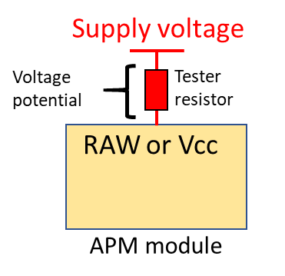

Figure A1 - Tester resistor configuration for determining current consumption

Firstly, a 3.3V and 5V power supply will be applied to the RAW pin of the APM module which feeds directly into the built-in fixed Low Dropout (LDO) voltage regulator (p/n MIC5205). This will measure the change in current consumed by the voltage regulator when the input voltage is the same as the output voltage and when there is a large difference between the input and output voltage. The next step will apply a 3.3V regulated voltage to the Vcc pin which bypasses the in-built regulation to check the change in current consumption.

Secondly, the ATMEGA328P processor used in the APM module is capable of being operating in different modes which consume different amounts of electrical current. The *lowpower.h* file developed by Rocketscream (<https://github.com/rocketscream/Low-Power>) is used to change the APM power operating mode. The test is carried out by cycling the APM module through the six modes of operation (*power on/normal mode*, *powerDown, powerSave, powerStandby, powerExtStandby and idle)* followed by a 5 second delay before the test cycle is repeated multiple times with each measurement averaged to increase the accuracy of the measurements.

Results



Figure A2 - Arduino Pro Mini current consumption measurements for each power mode operation

Table A1 - Arduino Pro Mini current consumption measurements tabulated results and averages



Testing Method

The testing configuration for all three RFM96 LoRa module tests are the same with the current consumption of the module being calculated using a tester resistor in series between the power supply and the 3.3V pin on the LoRa module. The RFM96 software is configured such that the radio operates at 437Mhz in the LoRa packet mode with the (0) default radio settings are used [Bandwidth = 125 kHz, Coding rate = 4/5, Spreading factor = 7 (128 chips/symbol) and Cyclic Redundancy Check (CRC) on]. It is noted that the (0) default radio settings is for medium range, medium data rate applications but it will allow the current consumption of the radio to be characterized with the final radio settings being determined by the testing of the communications link. The configuration of the APM processor and LoRa radio module used for all LoRa consumption testing is shown below in Figure B1.

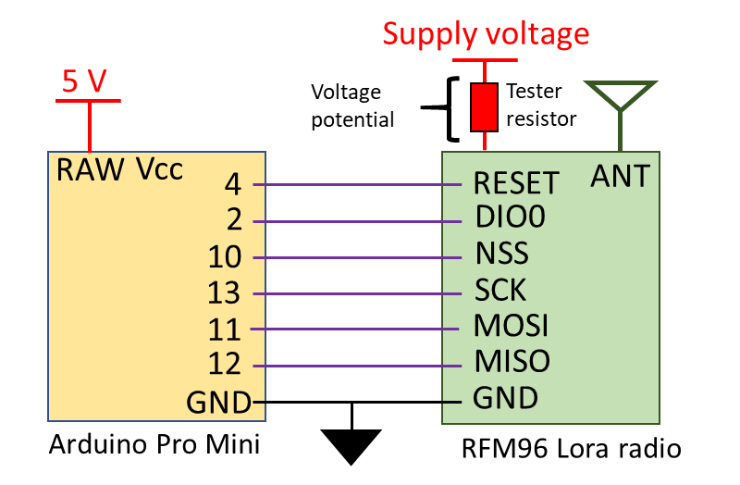

Figure B1- LoRa radio testing configuration and connections

The first test will determine the current consumption of the LoRa radio module during each mode of radio operation (*sleep, receive, transmit and idle*) available using the RadioHead library developed by Airspayce (<https://www.airspayce.com/mikem/arduino/RadioHead/>). Each mode of radio operation will be activated in sequence during one testing cycle which is repeated several times with different values of tester resistor to find the average current consumption. When the radio is set to *transmit* mode there is no data being transmitted from the LoRa module with the idle consumption of the transmit mode being checked and not the active mode which will be checked in the next test.

The second test will check the difference in current consumption of the LoRa module transmitting 30 bytes of data when the transmit power is increased from 5dBm to 23dBm. The transmit power is increased in 1dBm increments over several transmit cycles using different values of tester resistors to determine the average current consumption of the radio module.

The last test will measure the transmission time when the size of the transmitted radio packet is decreased from 250 bytes to 5 bytes in 5 byte increments when using a variety of transmit powers (5, 10, 15 and 20dBm). The current consumption will be measured using different tester resistors to average the results which are compared against the LoRa modem calculator tool supplied by the chip manufacturer, Semtech.

Results



Figure B1 - RFM96 LoRa module current consumption measurements during each mode of operation

Table B1 - RFM96 LoRa radio module current consumption measurement for each mode of operation





Figure B2 - RFM96 LoRa module current consumption measurements for each transmit power available

Table B2 - RFM96 LoRa radio module current consumption measurement for each transmit power available





Figure B3 - RFM96 LoRa radio module transmission time for a 5-byte incremented radio packet with 5dBm Tx power



Figure B4 - RFM96 LoRa radio module transmission time for a 5-byte incremented radio packet with 10dBm Tx power



Figure B5 - RFM96 LoRa radio module transmission time for a 5-byte incremented radio packet with 15dBm Tx power



Figure B6 - RFM96 LoRa radio module transmission time for a 5-byte incremented radio packet with 20dBm Tx power

Table B3 - RFM96 LoRa radio module transmission time measurements for varying transmit packet size



The major considerations when designing the software program are the requirement for no radio transmissions to occur for 30 minutes after launch, an inclusion of a period in the software cycle where the radio beacon can receive data and a variable period of time for when the radio beacon enters a power down state. There are several requirements that must be met when a satellite is released by a ride share launch provider with a major requirement being that no radio transmissions are to be carried out by the satellite for 30 minutes after the release from the launch vehicle. During the radio beacon software cycle, there must be a period where the LoRa radio can receive data from ground station. This will enable the radio beacon to receive a command from the ground to shut down the beacon radio transmissions which is a requirement of the International Telecommunication Union (ITU) when using the designated RF spectrum and also to receive a command that can be passed to another satellite system for emergency control. At the conclusion of the beacon software cycle, the amount of time that the system is powered down must vary to reduce risk of synchronisation occurring between multiple satellites. If the APM oscillator between 2 satellites were maintaining the same frequency and the radio beacon cycles where to align, then the transmissions from each satellite could interfere and cause a loss of transmission data from one of the satellites. To mitigate this risk of data loss, the power down time will be varied between each cycle to prevent synchronisation between satellite radio beacons occurring.

Testing was carried out to validate that the code developed in the Arduino IDE performs the necessary functions and processes defined in the software flow chart (refer Figure C1 below). This testing was carried out by running the radio beacon code through 100 software cycles to ensure that a 50-byte radio packet containing identification and telemetry data was sent from the radio beacon and received by a ground receiving station. The first 8 bytes of the radio packet contained the satellite identification *‘TravSat1’* and the remaining 42 bytes consisting of the telemetry data collected. A sample of satellite telemetry components was simulated such as measuring battery and solar panel voltage or checking light levels from several LEDs is performed during the collection of satellite telemetry data phase. The solar panel voltage is an incrementing counter from 0 to 100 to ensure that all packets are correctly received with any missed or dropped packets easily identified.

The software code was modified such that if a command was received from a ground station during the *receive* phase then a printed message was displayed on the Arduino serial monitor validating that the beacon can receive a command and execute a function.

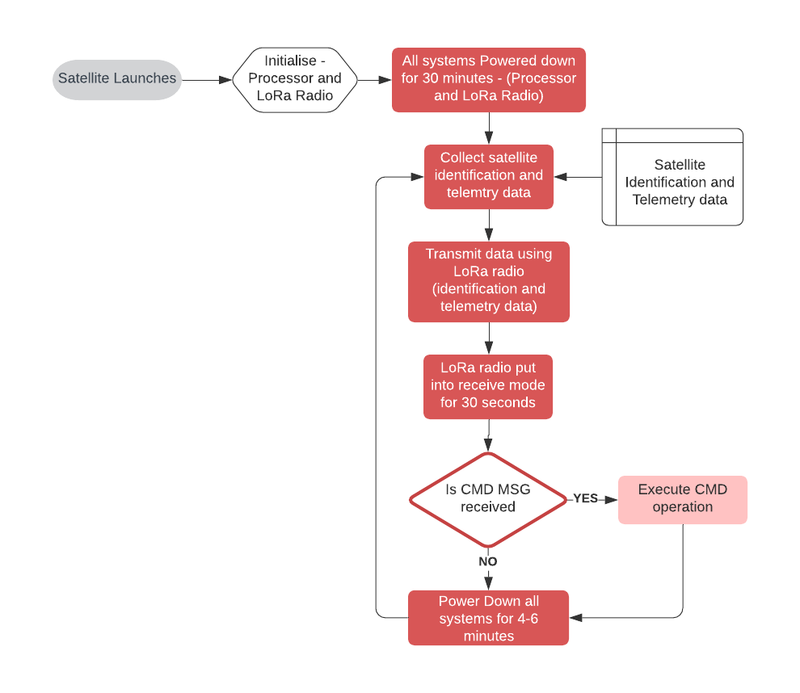

Figure C1 - Satellite radio beacon operational cycle software flow chart

Testing Method

The next investigation is reducing the current consumption of the beacon by utilising different electrical regulators for the electrical power system. The testing will be carried out by using a 5V, 1.5A wall power supply (the expected voltage for the solar panel is between 5-6V) being applied to a variety of regulators and running the satellite beacon through a shortened software cycle. The regulators that will be utilized for testing are:

1. MC5205 – APM module in-built Low-Noise LDO voltage regulator
2. LM1086 – LDO voltage positive regulator
3. LM3671 – Step-Down DC-DC converter (Buck converter)
4. TS2904CZ – Ultra LDO linear voltage regulator

The LoRa radio will use a TX power setting of 15dBm and will use the (2) RadioHead default settings [slow & long-range settings – BW = 31.25kHz, CR= 4/8, SF = 9 (512chips/symbol) and CRC on]. A 1Ω and 2Ω tester resistor will be placed in series with the power supply and regulator to measure the supply current with the testing configuration of the satellite beacon power regulator testing shown below in figure D1.

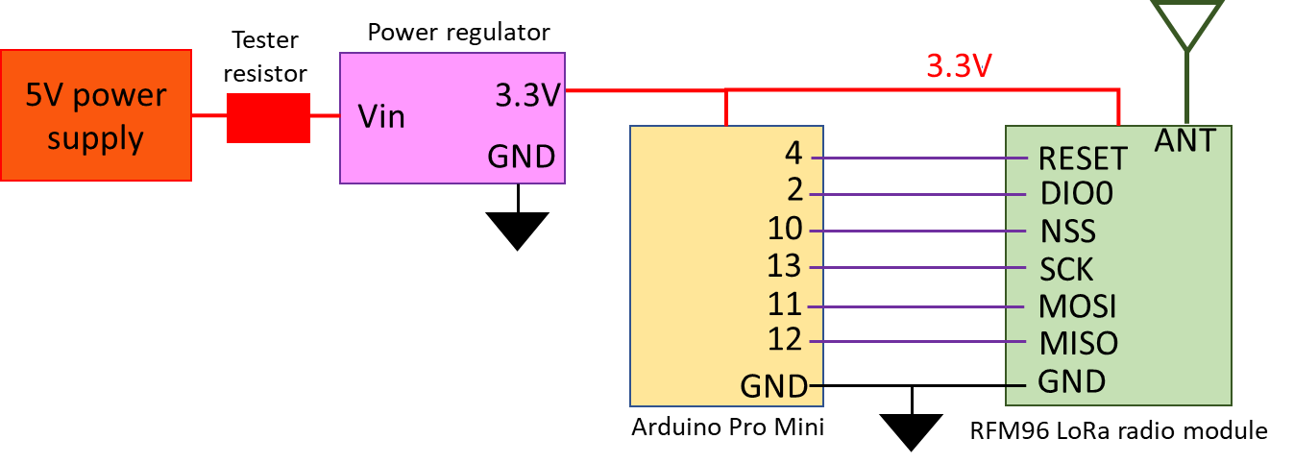

Figure D1 - Satellite beacon power regulator testing configuration

Results



Figure D2 - Satellite beacon current consumption when utilising different voltage regulators

Table D1 - Satellite current consumption measurements and averages for different voltage regulators



Testing Method

To determine the current drawn from the solar panels by the complete satellite radio beacon system (external LM3671 regulator, computer processor, LoRa radio module and attached components) during each phase of the software cycle, a tester resistor was placed between the solar panels and the breadboard positive power rail which supplies the power for all the other sub-systems components. The transmit power of the RFM96 LoRa radio module was set to 15dBm with the radio using the (2) RadioHead default settings (long range settings). The testing program used was a shortened version of the software cycle where the launch lasts for 5 seconds, the receive mode is 3 seconds and the idle/low power mode is 2 seconds.

The results from testing the current consumption of the satellite beacon provided evidence that the radio beacon was unable to be operated with one solar panel connected if the transmission power was greater than 10dBm as the current required for continuous operation was larger than the current being supplies by one solar panel. This prompted an investigation to find a solution where the transmit power can be increased while operating the beacon using one solar panel. This led to including five 2.2mF electrolytic capacitors in parallel with the solar panels which stores approximately 0.17 joules of energy that could be used during the transmit phase to stabilize the power system and provide enough energy for the transit current spike. The configuration of the satellite radio beacon used for the total power requirement and generation testing is presented below in Figure E1.

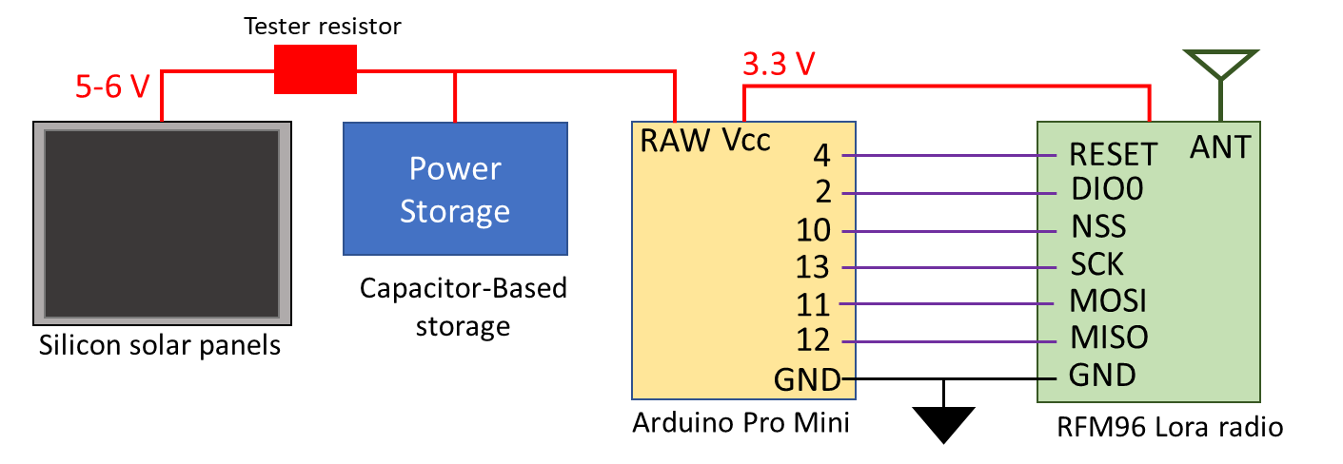

Figure E1 - Satellite radio beacon configuration for power requirement and generation testing

Results



Figure E2 - Satellite beacon total current consumption during each phase of the software cycle

Table E1 - Satellite beacon total current consumption measurements during each software cycle phase



The testing of including 11mF of electrolytic capacitance to store energy for the transmit phase was conducted by running the beacon through the shortened software cycle with one solar panel connected while increasing the transmit power from 5dBm to 23dBm in 1dBm increments. The shortened beacon software cycle with the same settings as the previous test was used to test the addition of supporting capacitors in the power system. At each power level, the software cycle was performed 10 times with operation of the beacon being sustained for all transmit power levels when connected to a single solar panel and five 2.2mF capacitors. The weather conditions for the day were clear and sunny with the orientation of the solar panels were perpendicular to the sun. It is noted that solar panels, in general, can generate approximately 20% more power in a space environment as the sunlight does not have to penetrate the Earth’s atmosphere. This will result in the beacon system having more power available when deployed in LEO with the excess providing a safety margin in the power generation system in lower irradiate conditions.

Testing Method

The last investigation for the satellite beacon begins by determining if the inclusion of a super capacitor in parallel with the solar panel can sustain the transmit phase of the software cycle when using one solar panel. Secondly, a measurement of the voltage level and charge time of the super-capacitor storage system, consisting of five 1F capacitors, when connected to no load and 1 or 2 solar panels. The capacitor storage system is then connected to the Satellite radio beacon (with the solar panels are disconnected) to determine the length of time that software cycle can be run using only the energy stored in the capacitors. The full satellite beacon software cycle will be used without the 30-minute launch cycle, a transmit power of 15dBm and the (2) RadioHead default radio settings. The final step for the super-capacitor storage test will have it connected, with no electrical energy in the capacitors, to one solar panel and the satellite radio beacon which has the same radio settings as the previous test but will operate the full satellite radio beacon software cycle. The electrical potential of the capacitors will be monitored to measure the charging characteristics after a simulated launch and through the first cycles of the software program as well as to measure the time it takes for the system to contain enough energy to initialise post launch. The final configuration of the satellite radio beacon for testing is shown below in Figure F1.

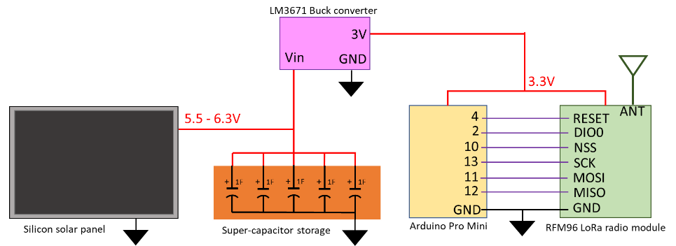

Figure F1 - Satellite radio beacon final configuration for testing

Results

When a singular 5.5V, 1F super-capacitor replaced the 11mF electrolytic capacitor as the energy storage medium then the electrical storage system was able to support the radio transmit phase. The inclusion of the super-capacitor in the power system causes a delay for the radio beacon to start once power begin generating. When one solar panel is used to charge a single super-capacitor then it takes 1 minute for power to be applied to the system, and when the number of super-capacitors is increased to 5 then the time increases to 7 minutes.



Figure F2 - Satellite beacon power storage charge and discharge voltage with 5F super-capacitor system

The no-load charging time testing of the super-capacitors using one solar panel is detailed above in Figure F2, with the results showing that the average time taken for five 1F super-capacitors to charge to full capacity when no load is connected is 24 minutes and 30 seconds using one solar panel. If two solar panel are connected, then the charging time decreases to 9 minutes and 20 second.

The average voltage potential of the super-capacitor storage system after a charging cycle was 6.3V which equals 101 Joules of energy stored in the five capacitors. The average operating time before the super-capacitor could not support the beacon operation is 1 hour, 13 minutes and 43 seconds for one charge of the super-capacitor storage system. Discontinuities in the power supply would cause the Satellite radio beacon software to reset when the voltage potential of the super-capacitor storage system reduced below 3V which typically occurred during the transmit phase of the software cycle. The results show that there is an 8 minute and 20 seconds delay from when the solar panel first start to generate electrical power until there is enough energy to initialize the radio beacon hardware and software in which the voltage potential of the capacitors measures 2.6V. The super-capacitor storage system reaches it full electrical potential after 27 minutes of operation when the software cycle is approximately 19 minutes into the low power launch phase.